Build 3.5 Play Testing: Variables

Game: Fling it Wing it

* Two player physics game.
* Targeted age 7-10 but opened to all age groups

Screenshots of current build

Figure 1: Players aiming

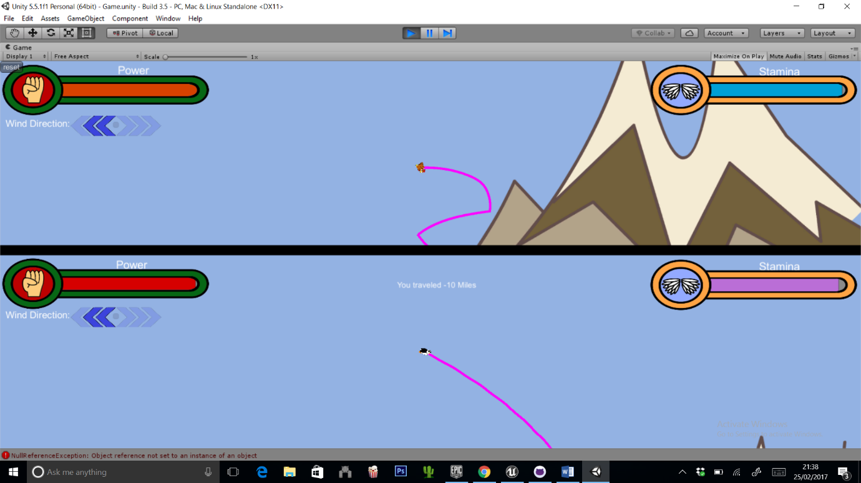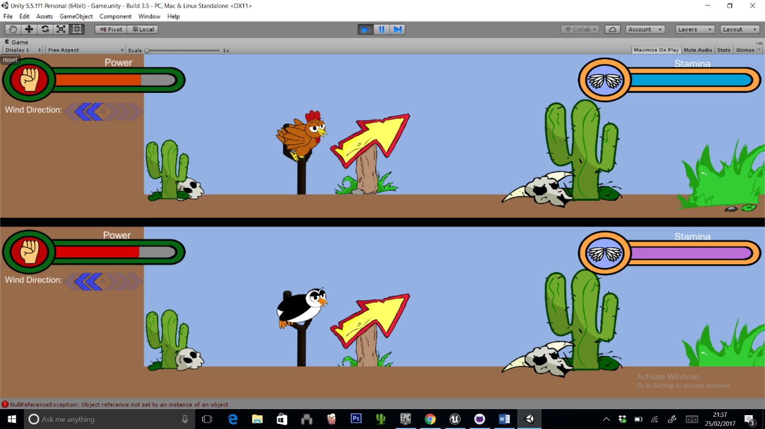

Figure 2 : player ball in the air

Player Details

* Player Gender:
* Player age:

Variables:

* How was the pacing of the game, too fast, too slow? Please elaborate:
* How was the power applied to the bird, too powerful, too weak? Please elaborate:
* How was the bounciness of the ground, too bouncy, not bouncy enough? Please elaborate:
* How was the power applied to the wind functionality, too strong? Not strong enough? Please elaborate: